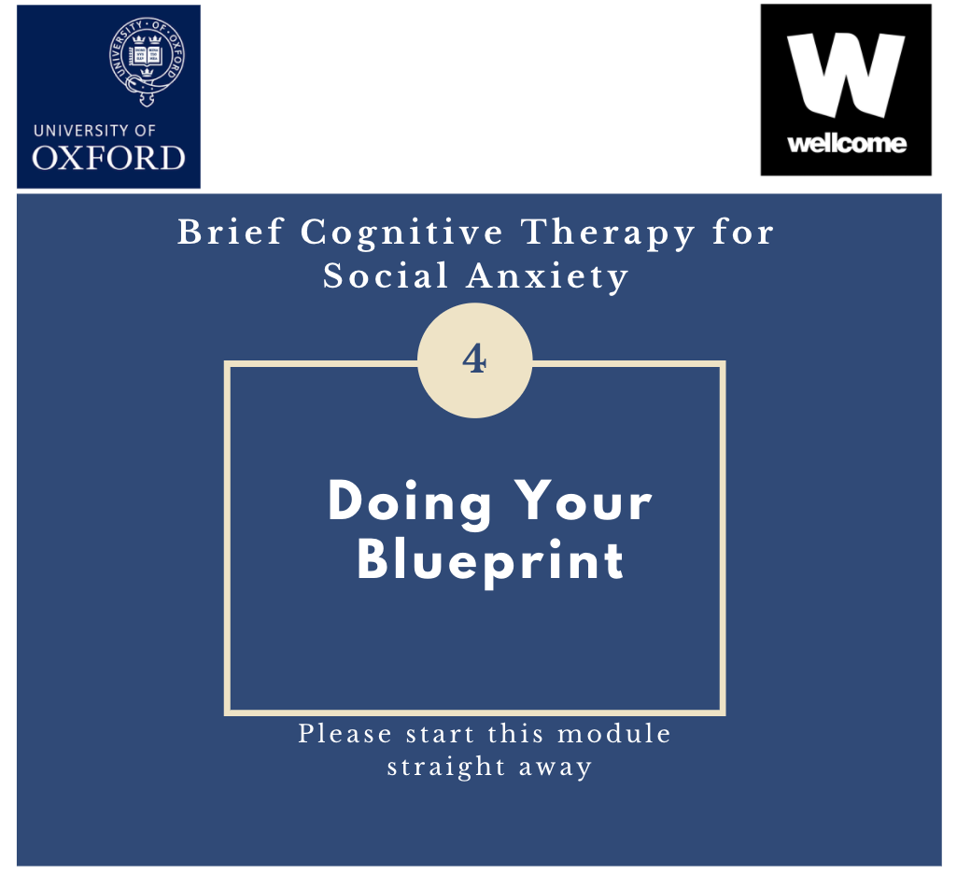
Agreed Homework for this week:

THERAPY BLUEPRINT

Towards the end of therapy, it is helpful to review treatment by writing out a Therapy Blueprint. The aim of the Blueprint is to try to summarise key points learnt, to help you focus on and reinforce the changes you have made, and to have clear strategies to build on the gains so far achieved. Once completed, it serves as an accessible overview of treatment which can be referred to in the future, particularly at difficult times.

Hopefully, you will have made some major changes and improvements in therapy, and we are sure you have worked very hard with these modules. Although ideally you won’t need to keep thinking about your social anxiety as your improvements just become natural and normal, everyone has ups and downs, and you may need to remind yourself of the things that you have learned. So, it is important to be as specific as possible when you complete this. You may know what everything means now, but in 6 months or 2 years time, if you are feeling anxious for whatever reason, it might not be quite so clear. Some people like to think of it as writing a letter to themselves in the future, so if you want you can directly address it to yourself.

The Blueprint is divided into 6 sections, focusing on how your problem developed, what you have learnt in therapy and how to take this forward. You may need to set aside an hour of your time to work on this, and it would be helpful to have your notes close at hand as this is an ideal opportunity to review every aspect of treatment, and particularly some of the key experiments carried out. What we are aiming for is your own personalised Therapy Blueprint which you can easily access in the future. It is also important to say that what you write now does not have to be set in stone. The idea is that you can keep adding to, reviewing and refining your own Blueprint so it best helps you take things forward.

On the next 3 pages is a blank Blueprint for you to fill in your own personal version. There are some written prompts to help you with each section. Following this, is an example of a previously completed Blueprint which you may like to look at before starting you own. Once you have completed the Blueprint, it would be helpful to review it with your therapist. You may even want to do the first edition as a draft. We really encourage you to see it as an on-going project that you keep amending and adding to.

BLUEPRINT FOR SOCIAL ANXIETY

- How did the problem develop?
(What were the experiences that led to your social anxiety? Can you remember when it started? Was anything significant happening at that time? Were there any later experiences that made your social anxiety worse?)

- What kept it going?
(Here it might be useful to mention focusing on yourself/self-monitoring and any difficulties that that caused; the safety behaviours/self protective strategies you engaged in and the difficulties that caused; and the importance you attached to the way you felt, rather than how you behaved at the time. Did you engage in anticipating what might happen and carry out post-mortems focusing on your feelings and discounting alternative feedback? Did you have a distorted image/impression of how you appeared based on the way you felt? Did you avoid situations?)

- What were your main negative thoughts? What answers did you develop to these thoughts?
(What were the most important negative thoughts and beliefs – what are the answers to these? Summarise the negative thoughts on the left hand side of the page, write any answers you developed on the right hand side, and make notes about why you believe the answers (e.g. the specific behavioural experiments that helped changed them.)

My main negative thoughts | My answers to these thoughts now

- What did you learn in therapy that was useful?
(What have you found helpful? Look back over the notes you have completed in your notes and remind yourself of key points learnt. Was there anything that particularly stands out for you? What did you learn about the role of Safety Behaviours? What did you learn about your internal focus of attention and the images/impressions you had of yourself? Has the negative image or impression you had of yourself changed during therapy? If so, how do you see yourself in social situations now? What did you personally find useful?)

- How should I deal with social situations in the future, including any setbacks?
(How can you maintain your new social self, your new way of being? What things might happen in the future to undermine your confidence? Will specific thoughts re-occur? Would you start to focus on yourself? Might you mistake how you feel for how you appear to others? What should you do if you notice a setback beginning – list the strategies that might be helpful. At this time, what would be the key things to remember and do? What experiments would help you get back on track?)

- How could you build on what you have learned?
(What do you need to do to maintain these changes and improvements? What is there still left to work on – an action plan might be helpful here. Are there still problem areas - anything you are still avoiding? How can you now “steal the limelight”, experiment with being the centre of attention – what future experiments would really take it all forward? How much do you really believe your new thoughts and way of seeing things – are there still any doubts – what can you do to target the doubt? Given what you have learnt, what would really help you maintain your new beliefs in the future?)

BLUEPRINT FOR SOCIAL ANXIETY

- How did the problem develop?

When I was about 13 years old, my parents moved house and I changed schools. I was bullied at my new school and it made me feel different to everyone else. From then on, I found it difficult to make friends and socialise, even when I changed to a 6th form college. I think I first realised the extent of the problem in my early twenties when I started my first job and still worried that others didn’t like me and found it hard to talk to the others in my office. This worsened when I was expected to speak up at meetings and found I would become nervous, self-conscious, worry about saying the wrong thing and worried that I would blush. I also had to do a reading at my brother’s wedding and worried about it for months beforehand which made me realise I really needed help.

- What Kept It Going?

My parents always lived in isolated rural places so this made it easy to withdraw and avoid seeing people outside school. I feel I didn’t really learn how to socialise as a child and this has carried over into adulthood. As an adult I have changed jobs a lot and had difficulty maintaining friendships. At work, on the occasions when I would be asked to contribute to a meeting or group, I would brood over it for weeks before, focusing on what was going to go wrong based on the way I felt and saw myself, and I lived in a state of controlled panic. I also went over and over what happened afterwards, again based on how I felt at the time, which I now know is not the true picture.

The problem was kept going in part because I kept avoiding social contact generally and avoided attending meetings so never got over my fears. When I had to go to a meeting, I would focus completely on how anxious I felt, focus on an image of myself as bright red, shaky and nervous, and never contribute. If asked a question, I would use ‘safety behaviours’ which were to cover my face with my hands which I now know make my face go red, and draw more attention to me, and keep my answers really short and quickly divert attention on to someone else so the attention wasn’t on me which meant I never had the chance to test out my fears. I also focussed on myself completely, I never looked up or around to see what was actually happening in the meeting and how others were weren’t reacting, which I know is the best thing to do. I also became obsessed with my own inadequacies and focused on everything that re-enforced that and if my fears didn’t happen, I saw it as a fluke and ignored it.

3. What were your main negative thoughts? What are the answers to these now?

I’ll blush, fidget and appear anxious socially and especially at meetings and in groups. This makes everyone think I’m weak and not good at my job.
Now I know although I feel anxious, others don’t notice it. I don’t blush or shake as much as I feel I do and people actually see me as competent at my job.

Experiment: Spoke to loads of different people during therapy and even though I felt red and shaky, none of them noticed, and rather than weak, described me as interesting and competent.

Wore blusher and no-one noticed. Deliberately shook in a meeting and no-one noticed.

I’m boring – I was worried that if I spoke at a meeting or in a group, I would fail to be interesting.

There is no evidence that people find me boring. When I worried I
was boring, I rarely contributed so no-one knew what I thought. Now I am talking more, most people have found what I’ve had to say quite interesting!

Experiment: Talked in groups and contributed to meetings and although I found it hard and felt like I was boring, when I looked around the room people seemed pretty engaged. One man was half asleep but he was like this for most of the meeting.

If I keep my voice monotone and in control it will stop me losing it.

Now I know if I put meaning in my voice, it helps me focus on what I’m saying and I give a more interesting talk.

When I dropped my safety behaviour of keeping tight control over my voice, I came across as more genuine and interesting.

I was worried that I would say things incorrectly and run out of things to say

I don’t worry about this so much.
I now know that pauses in conversation are normal, people don’t notice them, and it is ok to dry up in a meeting.

Experiment: Talked to people and allowed pauses, took no responsibility for keeping the conversation going. Deliberately dried up in a meeting and no-one made anything of it.

I think I was pressurising myself Now I know its OK just to be
into thinking I would always have average
to give an excellent speech

I used to think I had spend hours Now I think notes get in the way. My
preparing for any meeting writing contribution is more stilted with
notes word for word and if I didn’t notes and less natural or interesting
it would be a total disaster and I am less able to pick up on
other’s comments

Experiment: Gave two talks, one putting myself under pressure to be perfect, witty and the best. Prepared it well and made copious notes. The 2nd I dropped my standards and just said what I thought needed saying and made bullet points to remind me of key issues.

4. What did you learn in therapy that was useful?

Lots! I’ve learnt to recognise and drop my ‘safety behaviours’ (i.e. over-preparing, rehearsing in my mind, not allowing any gaps in conversation) and that I perform better without them. I’ve also learnt to question and challenge the thoughts that were perpetuating my shyness.

One of the key factors was realising how unhelpful it was to self-monitor and focus on myself all the time. It meant I was always overwhelmed by my own feelings and distorted images, and couldn’t pick up on what was really happening, and had no mental capacity to actually interact with others, never mind enjoy it!.

I’ve learned that I can contribute at a meeting or in a group as well as anyone else; that I don’t look as nervous as I thought I did; that I don’t look as anxious as I feel; that I don’t blush as much as I thought I did; that the image/impression of how I felt I was appearing is totally untrue; that its OK to look a bit nervous; that its better not to attempt to write out every word of a talk or conversation before-hand; that making eye-contact in a meeting helps me to talk in a more relaxed way; that its OK to ‘dry-up’ and be silent for a few seconds while collecting my thoughts.

I also learned that if I do talk off the cuff and not plan, others think it more interesting and I appear more relaxed and focus less on myself.

I also learnt that people don’t think I’m boring or weak and don’t necessarily notice my anxiety.

5. How should I deal with social situations in the future, including any setbacks?

I will keep reminding myself that there really isn’t anything to worry about. I will try to be less obsessed with my own nervousness. If asked to contribute to a meeting, I won’t feel I need to write down the precise words I am going to say – just bullet points. If I do dry up, get nervous or blush, I will try not to let it bother me – just press on and focus on the matter in hand, knowing that it gets easier as I go along and that although I feel like this, no-one is noticing.

If I notice I am becoming more anxious, starting to avoid situations, and more self conscious again I will:

- Remind myself of all the experiments I have done in therapy.
- Look back over the written feedback.
- Watch the video of me giving a talk at the Unit
- Create an experiment to get me back there – i.e. give a talk at work or ‘steal’ everyone’s attention at a meeting.
- Re-read this Blueprint!
- Use a flashcard with key points on it as a prompt (or put it on my mobile)
*Don’t Avoid
*Feelings Are Not Facts
*No Safety Behaviours
*Focus Externally (i.e. concentrate on what is happening rather than on myself)
*Remind myself I am not the focus of everyone’s attention
*Ask myself - What other evidence do I need?

- How could you build on what you have learned?

I will continue to experiment with initiating conversations, expressing my opinions, going to social events after work and attend meetings and contribute at them.
I could also now volunteer to get involved in presentations at work.
I will continue to try to concentrate not on my own feelings, but on the people I’m talking to and the things I am saying
If I am worrying beforehand, I will continue to test the anxious predictions I am making
If I feel anxious, or that I am blushing or shaking, I will practice focusing outside myself as much as possible, and look to see where others have their attention.

The one thing I still haven’t done, is talk at a big social gathering like a leaving party or wedding. My parents have their 50th wedding anniversary coming up and people have already indicated to me that a small speech would be nice, so I can use this as an ideal opportunity to test out my fears!

Your feedback

We have recently developed these modules as part of our long-standing treatment for Social Anxiety. It is important for us to continually develop our treatment so that we can offer the best possible help for people with this problem.

We would be grateful if you could give us your feedback on this module.

What have you found helpful in this module?

Were there any parts of this module that you found difficult to use, or hard to understand?

Are there any changes which you suggest we should make to this module, or any suggestions for how we could make it more user-friendly?

Any other feedback? (please continue overleaf if needed)

Thank you!

